 | Pimpri Chinchwad Education Trust’s  Pimpri Chinchwad College of Engineering  (PCCoE)  (An Autonomous Institute)  Affiliated to Savitribai Phule Pune University(SPPU) ISO 21001:2018 Certified by TUV | 
Course: DevOps Laboratory | Code: BIT26VS01
Name: Amar Vaijinath Chavan | PRN: 124B2F001
Assignment 4: Create a Freestyle Jenkins job: Configure a job to print "Hello, Jenkins!" in the console output and view logs.

Aim: To create a basic Freestyle job in Jenkins, execute a shell command on the Master node, and
Analyze the console output .

Objectives:
- To understand the Jenkins Freestyle project workspace.
- To learn the process of manual build triggering.
- To study how Jenkins captures and displays logs on the Controller (Master) node.
Prerequisites:
- Jenkins Master node installed and running on AWS EC2.
- Admin access to the Jenkins Dashboard.

Theory:
1. Freestyle Project on Master
In a standard Jenkins setup, the Master node can act as its own execution agent. This is useful for
simple administrative tasks or initial testing. A Freestyle job provides a menu-driven interface to
define these tasks without needing complex Groovy scripts.

2. Workspace Management
When a job runs on the Master, Jenkins creates a specific directory called a Workspace (usually
located at /var/lib/jenkins/workspace/). This is where Jenkins performs the work and stores any
temporary files generated during the build.

3. Console Output
The Console Output is the "heart" of Jenkins debugging. It provides a transparent view of:
- Who triggered the build.
- Where the build is running (Master vs. Worker).
- What commands were executed.
- The Result (Success/Failure status).

Practical Procedure / Steps:
Step 1: Create the Job
- Open the Jenkins Dashboard and click New Item.
- Name the project: <First-Jenkins-Job>.
- Select Freestyle project and click OK.
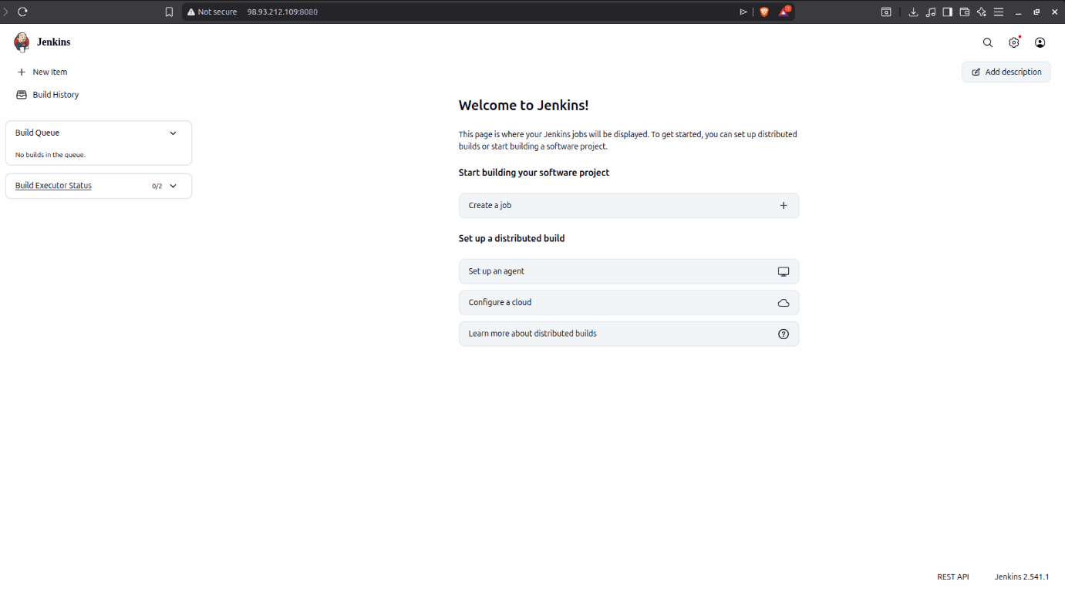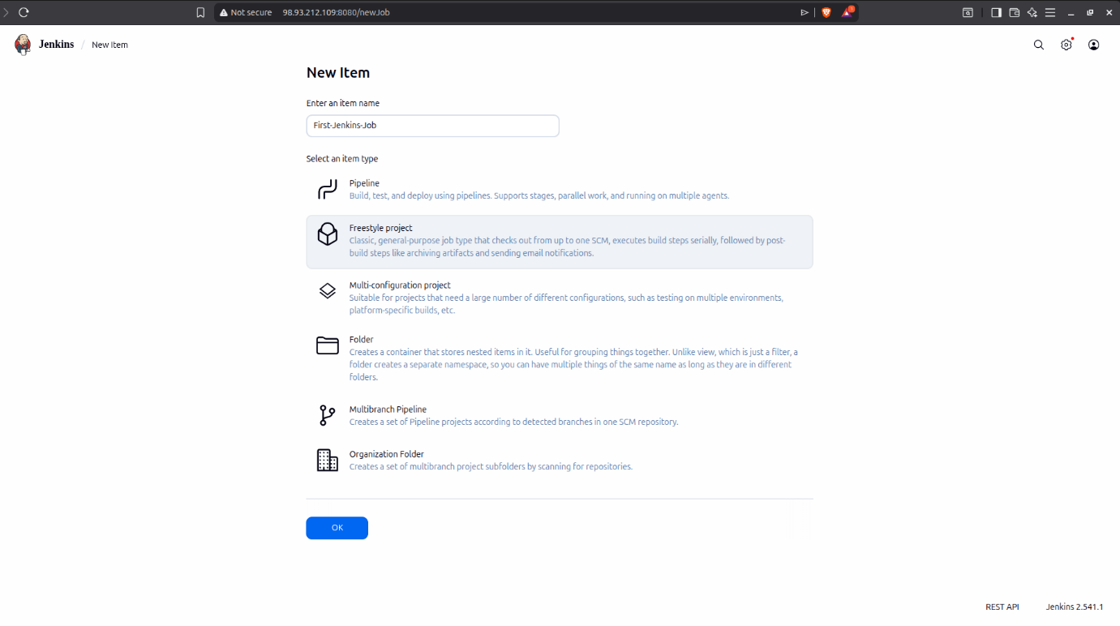
Step 2: Restricting to Master (Internal Logic)
Since we are not using the worker node for this task, we ensure it runs on the Master.
- Under the General tab, ensure the option "Restrict where this project can be run" is unchecked, or specifically label it as built-in (the default label for the Master node).
Step 3: Add Build Step
- Scroll down to the Build Steps section.
- Click Add build step -> Execute shell.
- Enter the command:

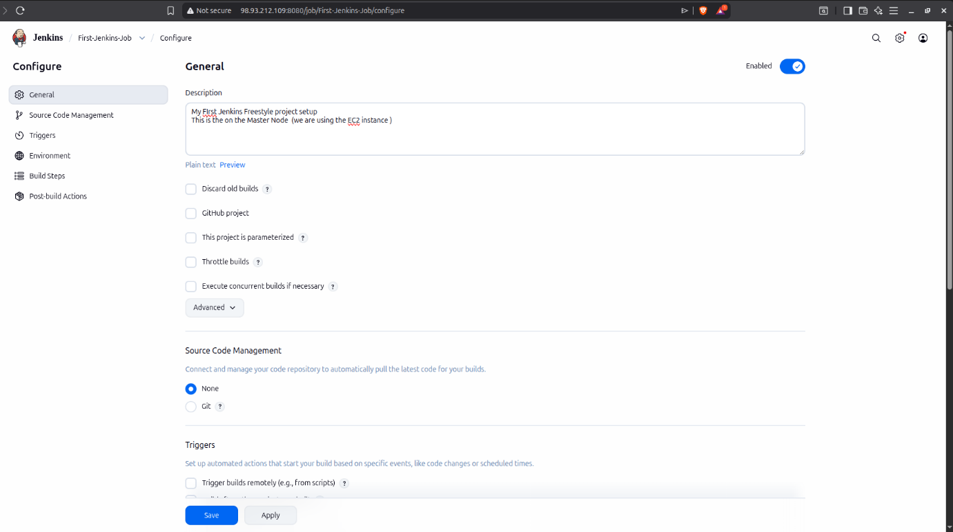

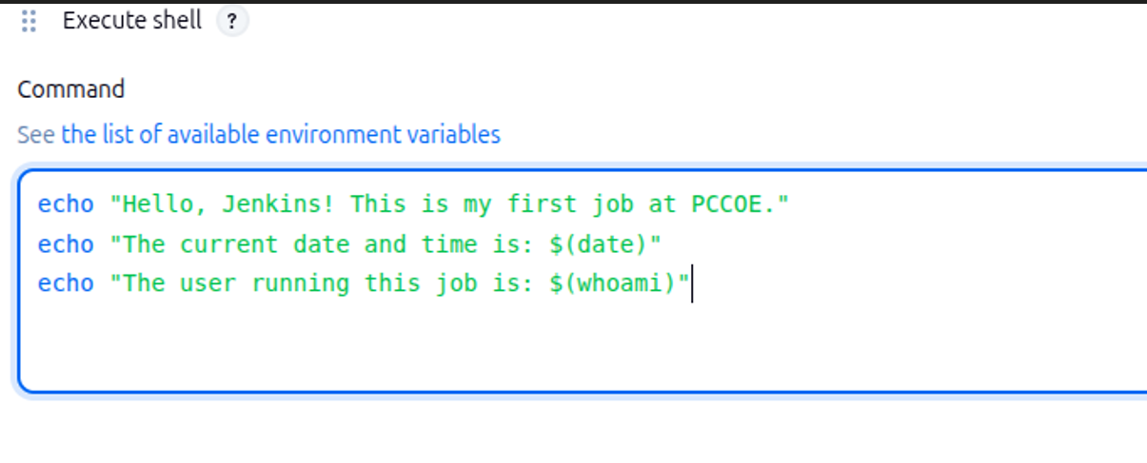
Step 4: Execute and Verify
- Click Save and then click Build Now.
- Once the build appears in the Build History (Green circle), click on the build number.
- Click Console Output.
- Check in the EC2 Machine (Terminal) /var/lib/jenkins/workspace/ the project folder is created.
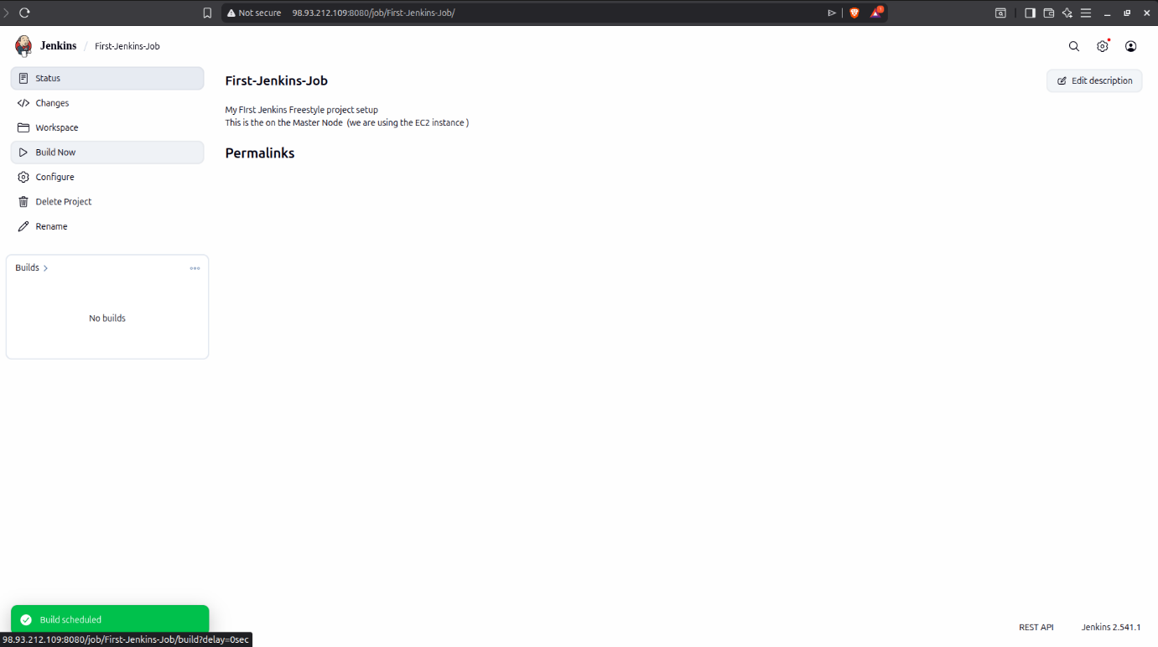

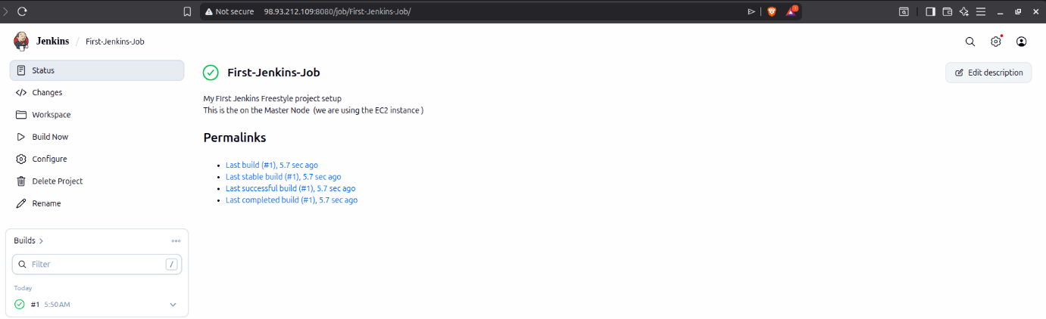

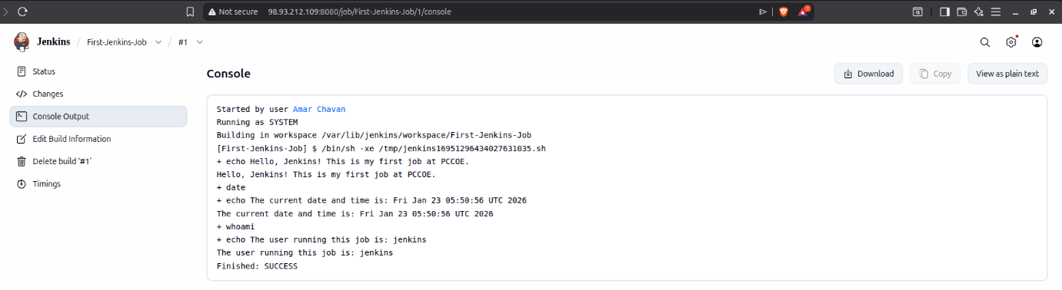

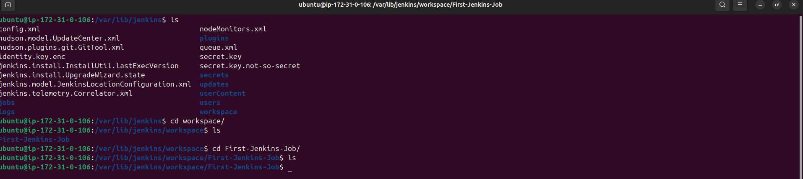

Conclusion:
The successful execution of this assignment demonstrates the fundamental capability of Jenkins to automate simple command-line tasks through a Freestyle Project. By running the job directly on the Master (Controller) node, we observed how Jenkins manages its internal Workspace environment, automatically creating dedicated directories for each project to ensure organized file handling. The analysis of the Console Output highlighted the transparency of the Jenkins build process, providing a detailed audit trail of the user who triggered the event, the exact commands executed, and the final status of the operation. This process serves as the essential first step in understanding CI/CD automation, proving that the Jenkins environment is correctly configured to handle script execution. Furthermore, verifying the physical folder creation within the EC2 terminal (/var/lib/jenkins/workspace/) bridged the gap between the web-based UI and the underlying Linux filesystem. Ultimately, this assignment establishes a solid foundation for more complex automation tasks, such as source code integration and distributed building across multiple worker nodes.

